**Cross the Road**

1. Create the following background as a bitmap(not a vector graphic).

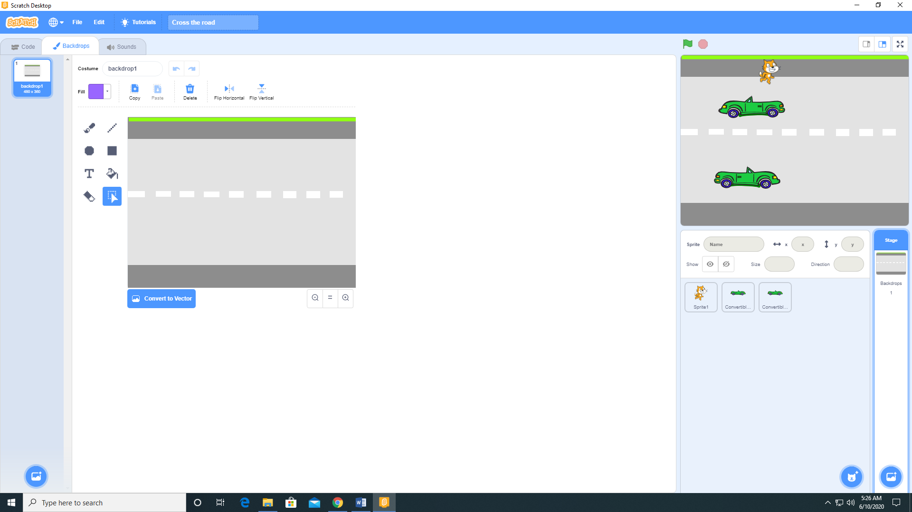

1. Add one Automobile sprites to your stage (I used the Convertible 2 sprite). Do not worry about the orientation.

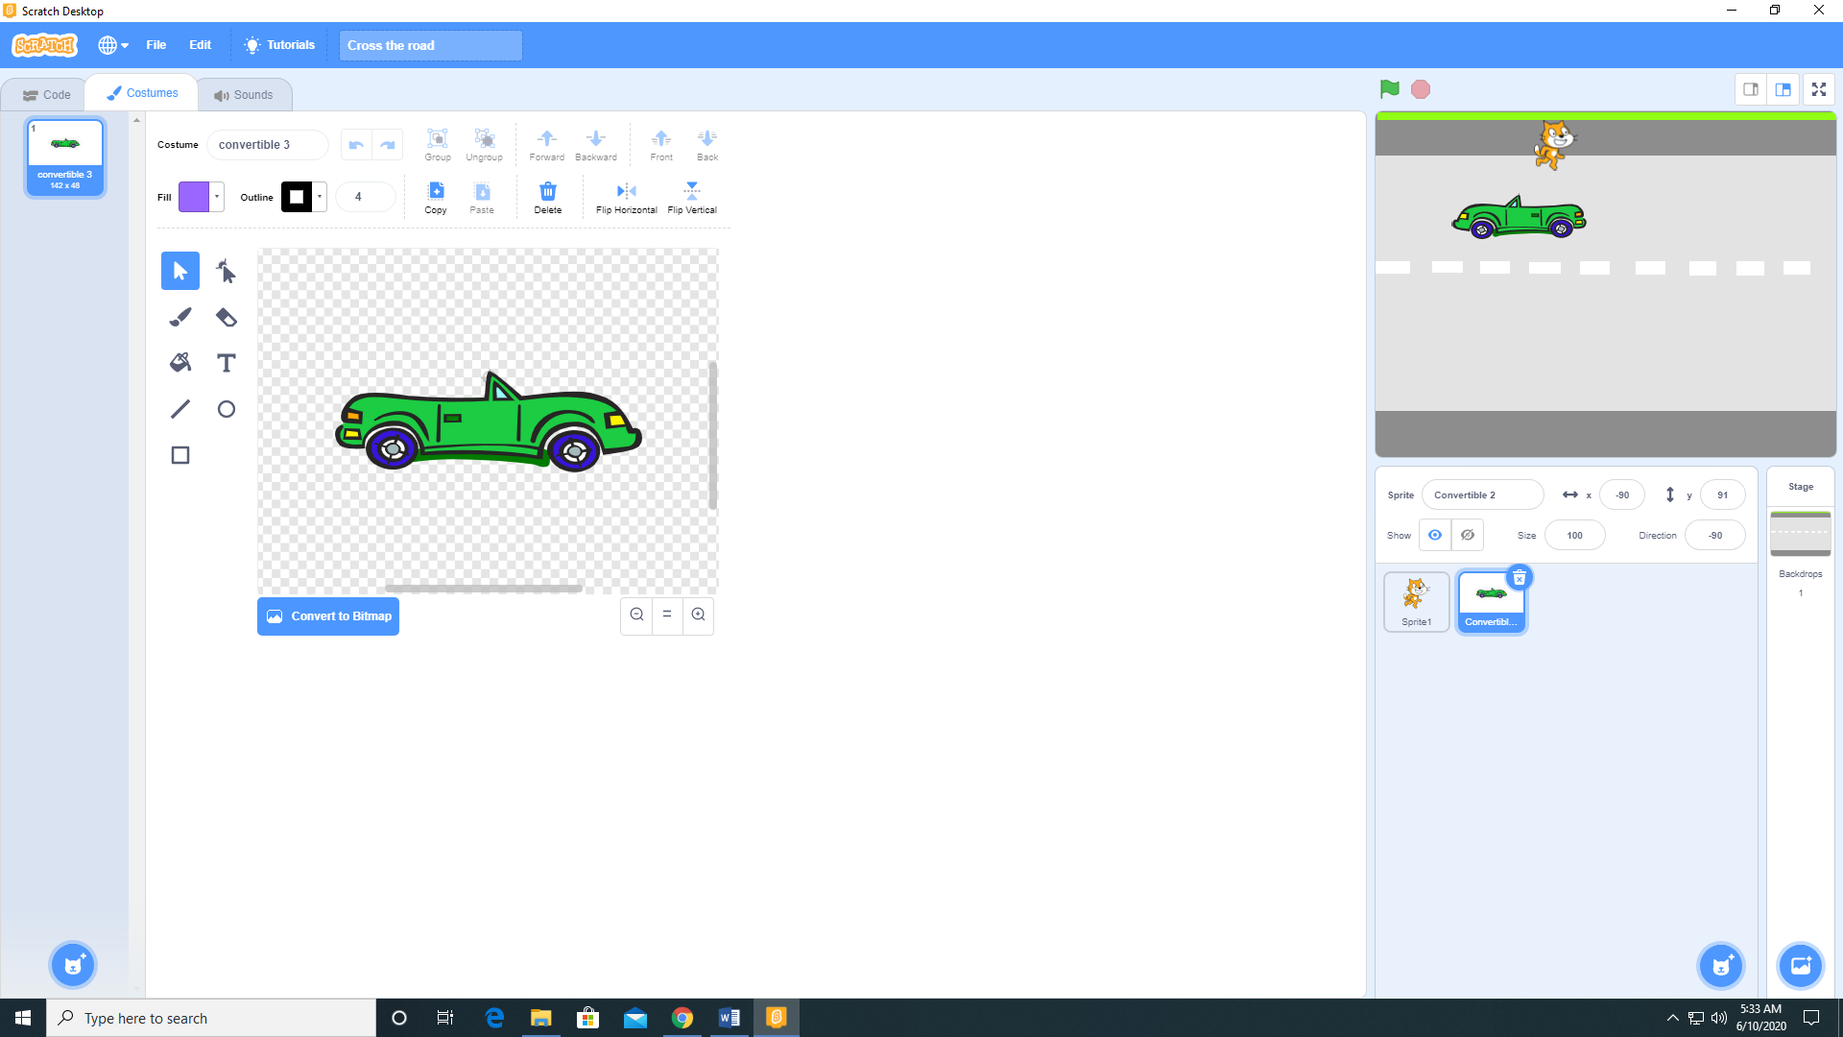

1. Add the following code to Sprite 1 (the cat)

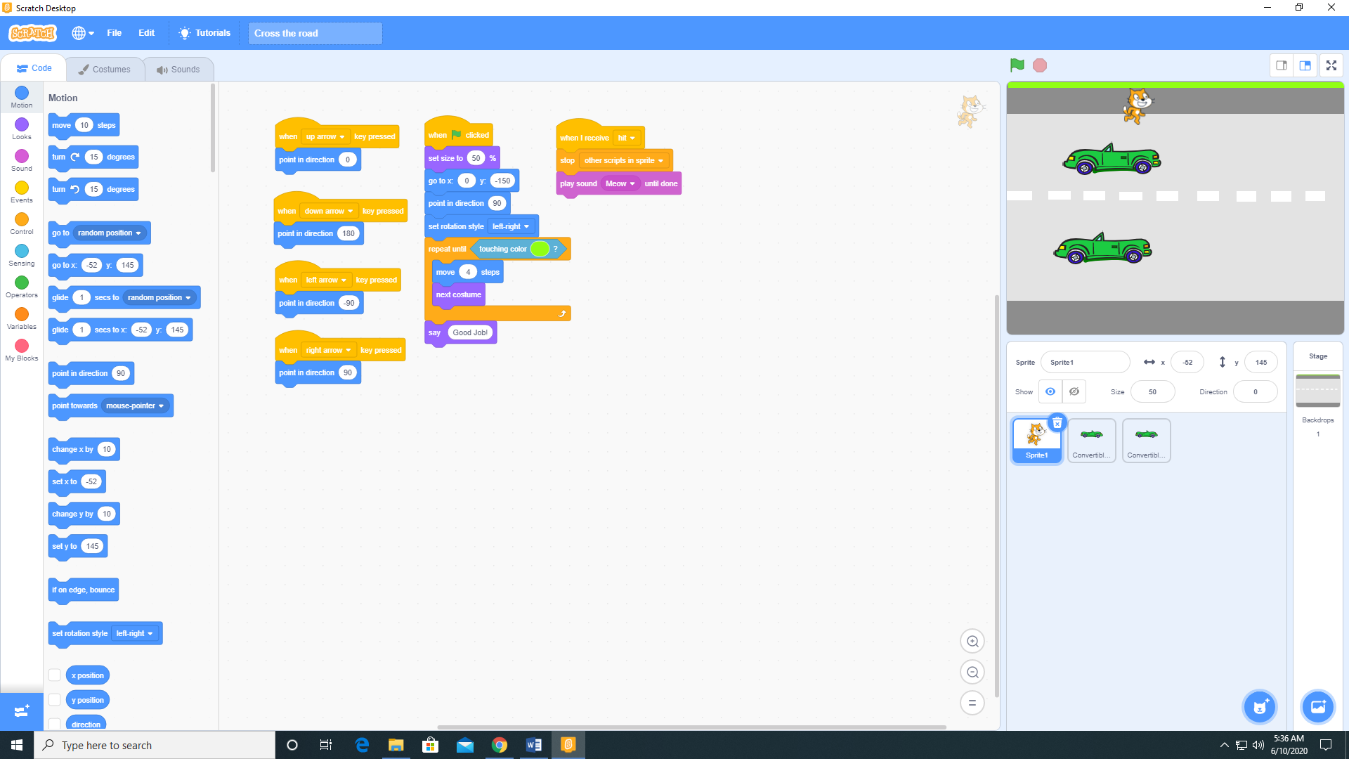

1. Add the following code to the Convertible 2 sprite.

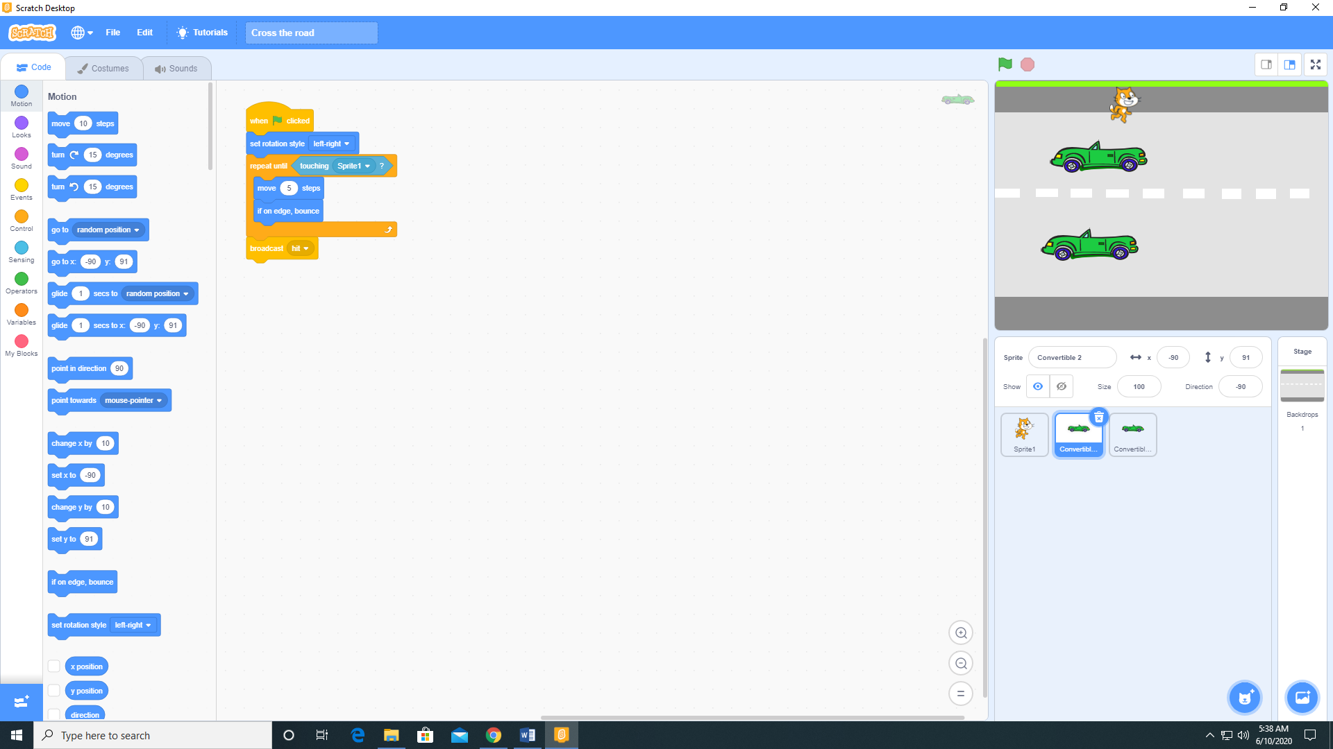

1. Add a second automobile to the stage by duplicating the first automobile. Orientation does not matter. Note: by duplicating the first automobile, not only the sprite is duplicate, but the code for the sprite as well.

